One day visit to RBI: On Thursday, October 13, 2022, the department of economics organised a visit to the Reserve Bank of India (RBI) Regional Office in Jammu for its scholars, students, and faculty. Although the purpose of the trip was primarily educational, the students' exposure to real-world dynamics helped them gain knowledge that went beyond what they learned in school. The Indian economy's database, particularly its banking information and other aspects of survey-based research done for monetary formulation, was explained to the students. The opportunity for students and scholars to engage in direct dialogue with those who make such substantial contributions to the financial system was enlightening.
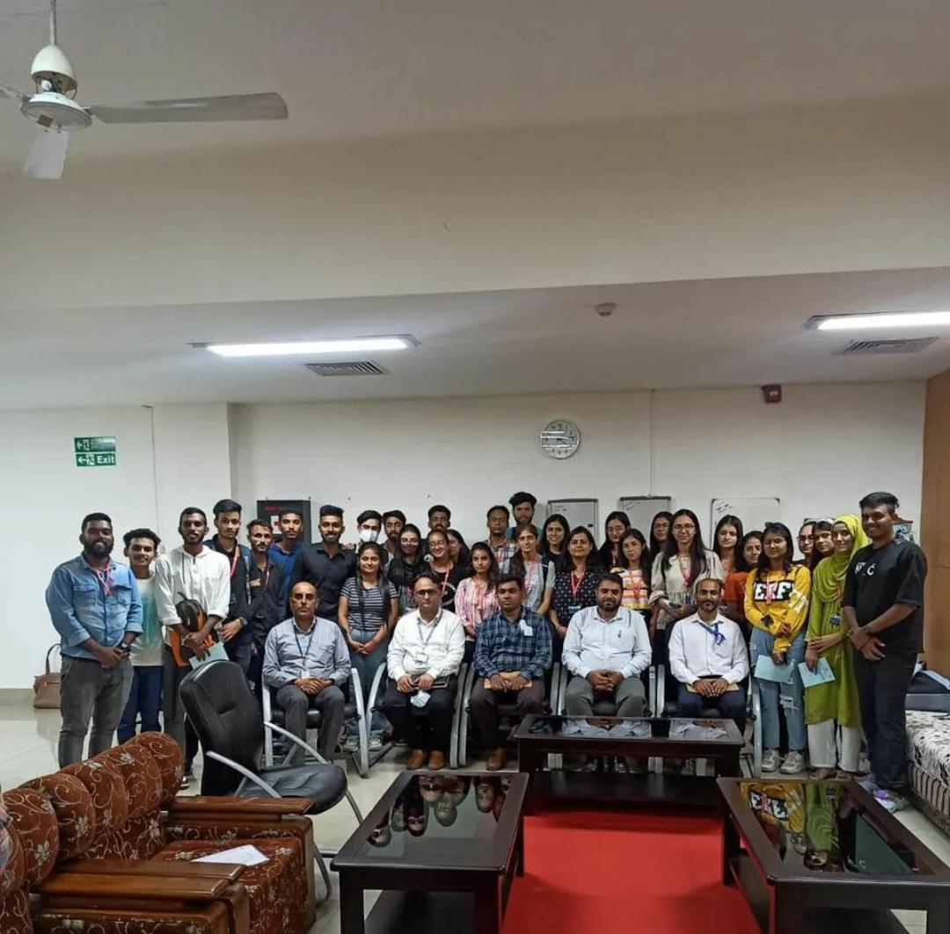

Greet and Meet session with Alumnus: The Department of Economics hosts a masters-level student interaction event with a department alumnus every two months. The event for this month was held on November 24, 2022, and featured Miss Ananya Khajuria, a graduate of the department from the class of 2017–19. She engaged in conversation with the current first- and third-semester batch of students. She shared her preparation strategies for the UGC-NET exam during the meeting, which focused on discussion and insights on this exam.
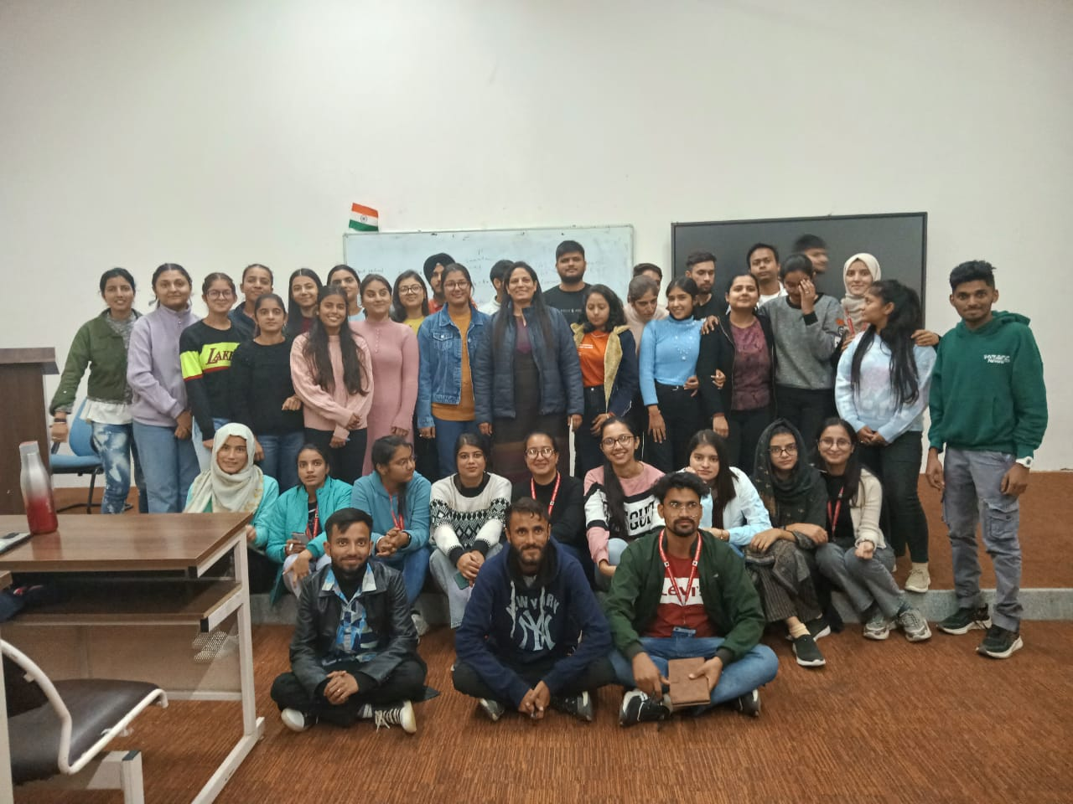

One-day Workshop on “Accessing database on Indian Economy”: The Department of Economics held a one-day workshop on "Accessing Database on Indian Economy" on December 8, 2022. Dr. Mohd Anwar, Assistant Advisor DSIM, RBI, served as the workshop's resource. The workshop offered practical instruction on how to access Indian economy data that is in the public domain of the RBI. During the session, database on various sectors, including the real estate, banking, corporate, external, and financial sectors, were explored.
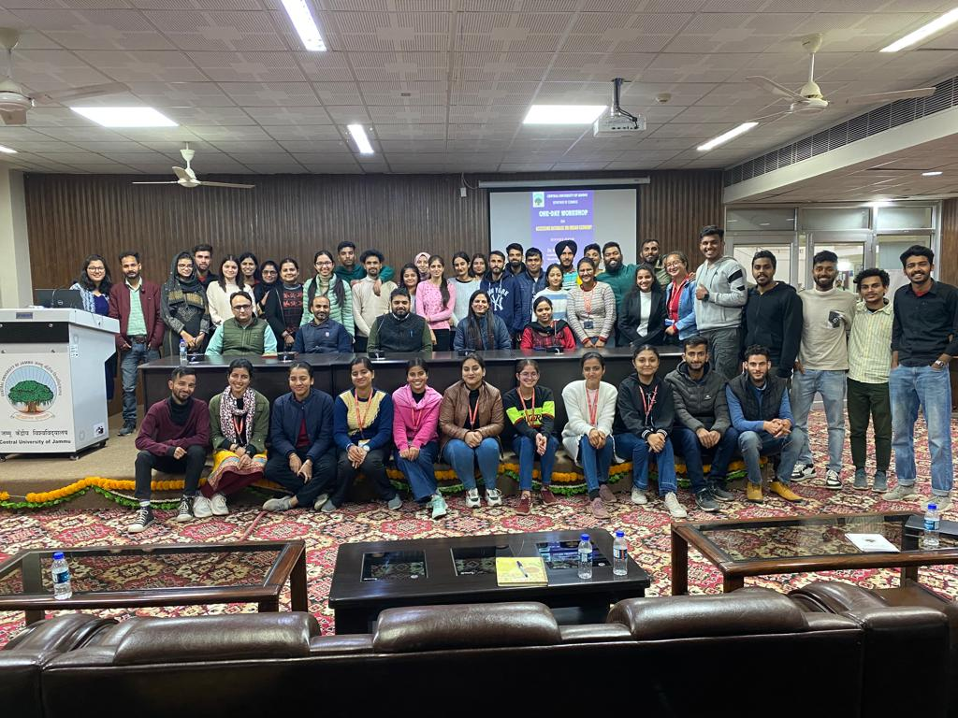

Decoding Budget 2023: On February 2, 2023, the Department of Economics hosted a discussion on the Union Budget 2023 in the Brig Rajinder Singh Auditorium. Students and academics from the economics department attended the event. The event began with the budget being streamed on video, which was followed by a discussion in which each faculty member shared their opinions on the budget. The occasion provided students with information about the union budget, the various economic reforms covered in it, and the function of the budget in fostering economic and industrial growth.
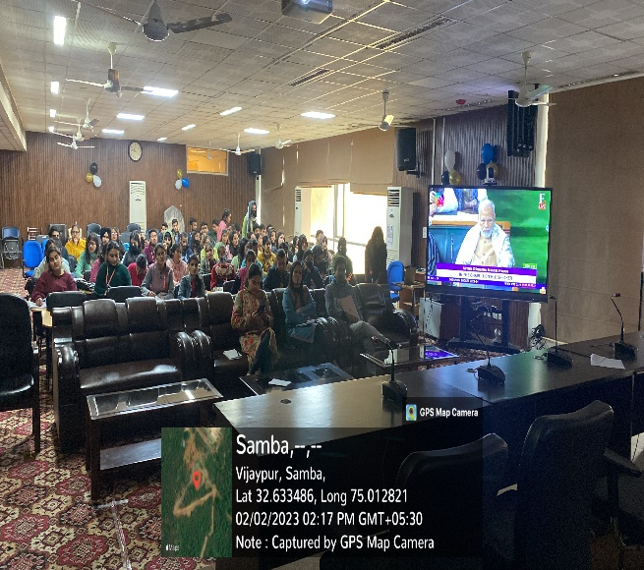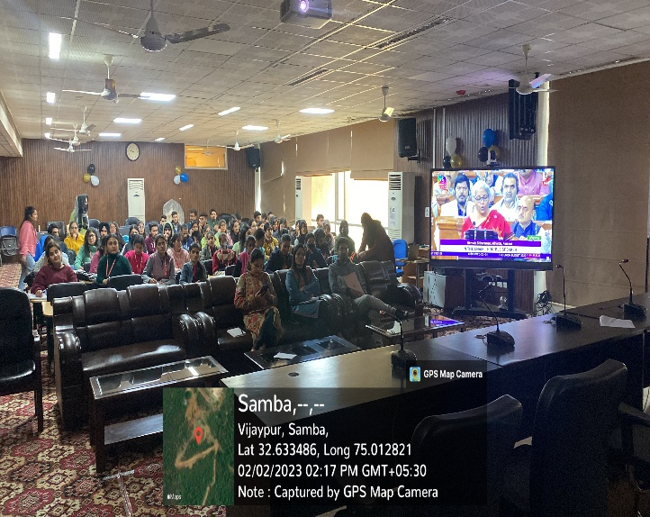

Fresher’s Party: The 4th Semester Economics Department students hosted a fresher's party for their juniors. The occasion was a riot of joy, music, excitement, laughter, and happiness. Seniors welcomed first-semester students with great enthusiasm. On January 18, 2023, the event was held in the Brig. Rajinder Singh Auditorium. The event was also attended by departmental scholars and faculty members..
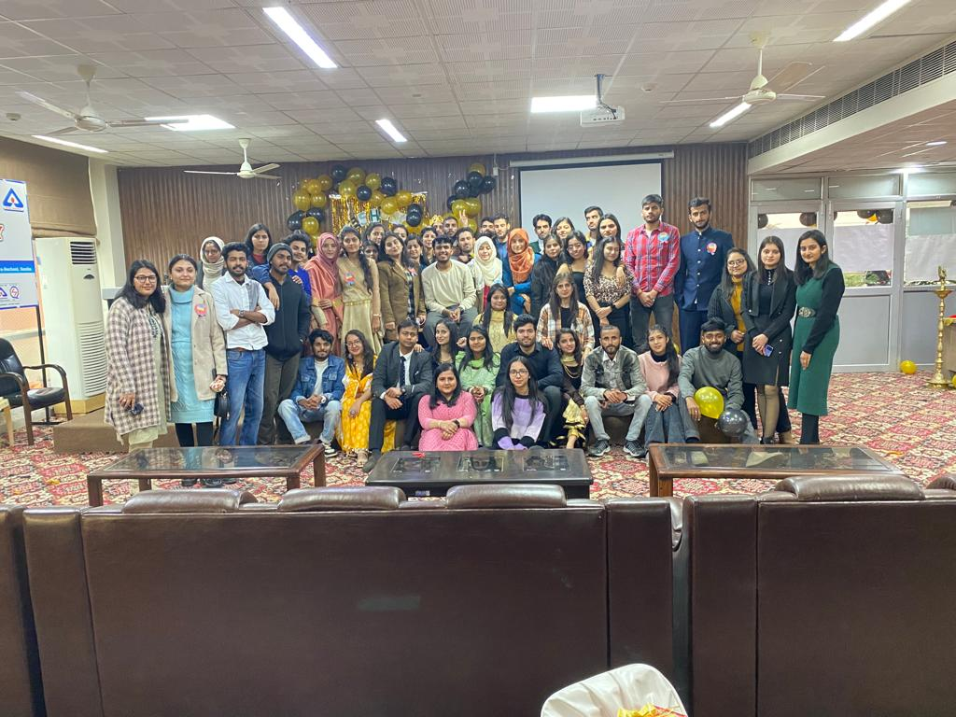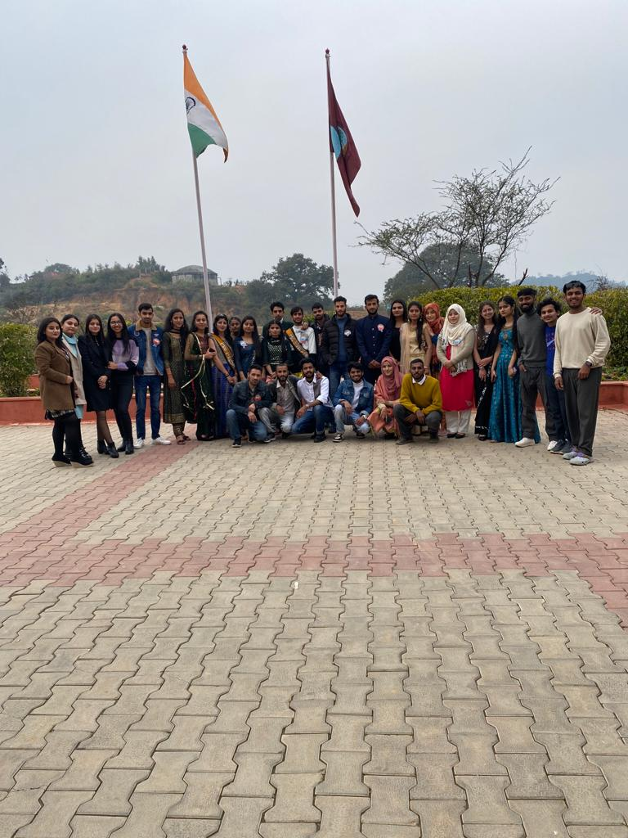
One- Day workshop on Resume Building: The Department of Economics at CUJ hosted a one-day workshop on resume building on Tuesday, February 14, 2023 from 12:00 to 1:00. Mr. Viraj Magotra, Training & Placement Officer, CUJ, served as the workshop's resource person for fourth-semester (M.A.) Economics students.
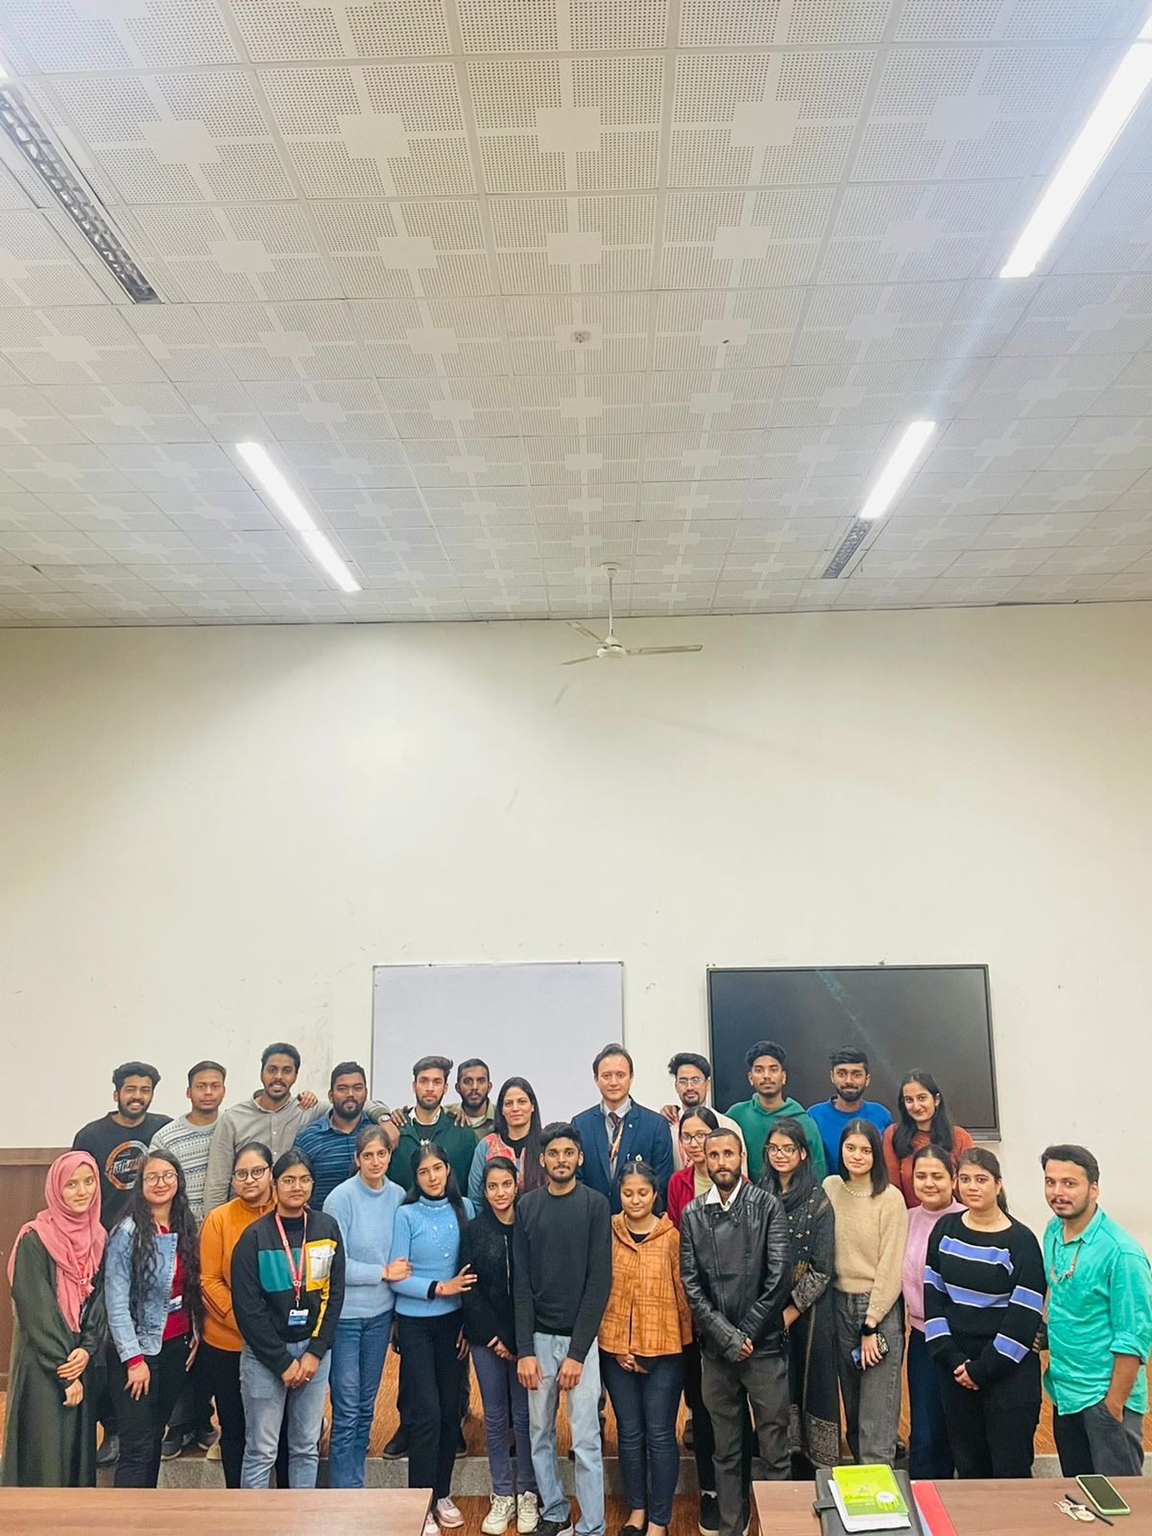

Phd. Viva-Voce (Final Oral Open Defence) of Ms Sumanpreet Kour, Enrollment No. 0110114, Research Scholar was organized by the Department of Economics, under the School of Humanities and Social Sciences, on March 15, 2023 from 2:30-5:00 PM, through blended mode in room B-06 of DDE building.
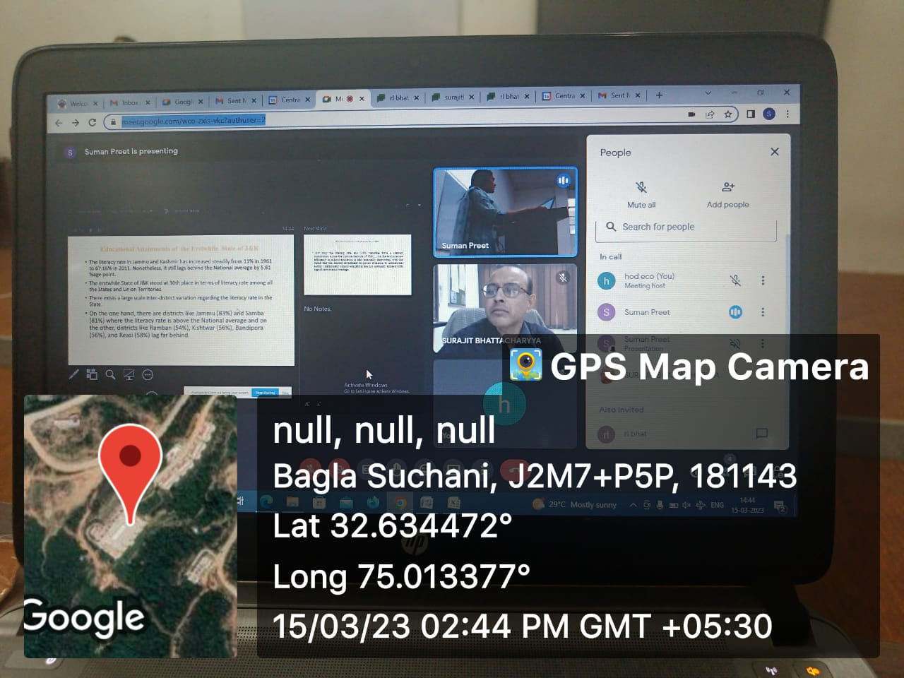

Trip to Suchetgarh: On May 6, 2023, the Department of Economics at CUJ has planned a one-day educational excursion to the Suchetgarh Border. The daylong excursion was organised with the intention of giving the students something to do for fun. The students' enthusiasm and sense of patriotism were also sparked by the trip. The students have learned many practical concepts about geopolitics, intercultural communication, and international relations thanks to this educational excursion. The purpose of the excursion was to give the students a firsthand understanding of border dynamics and international relationships. The students had the chance to participate in educational workshops about the border's significance and history while they were there. They received an invitation to the evening procession as well.
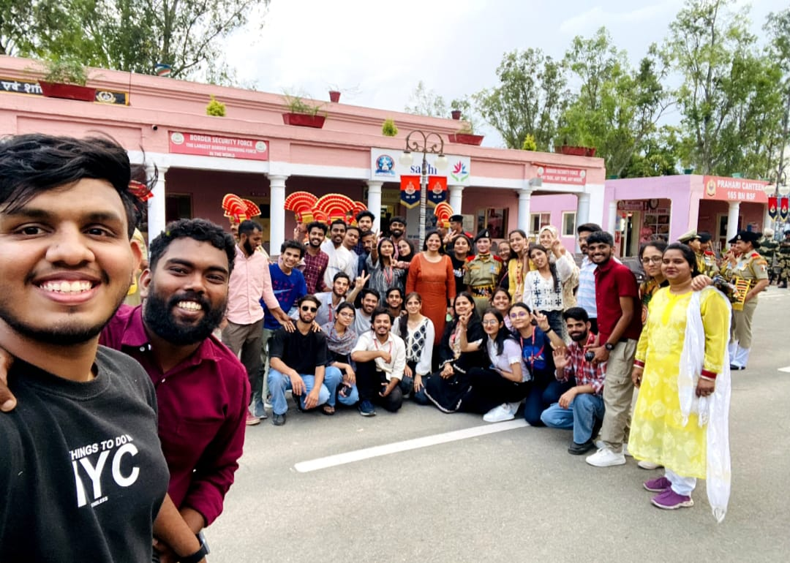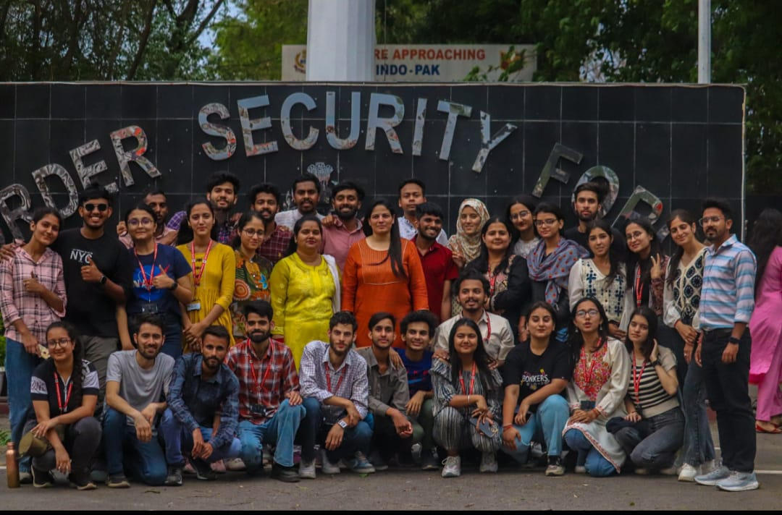
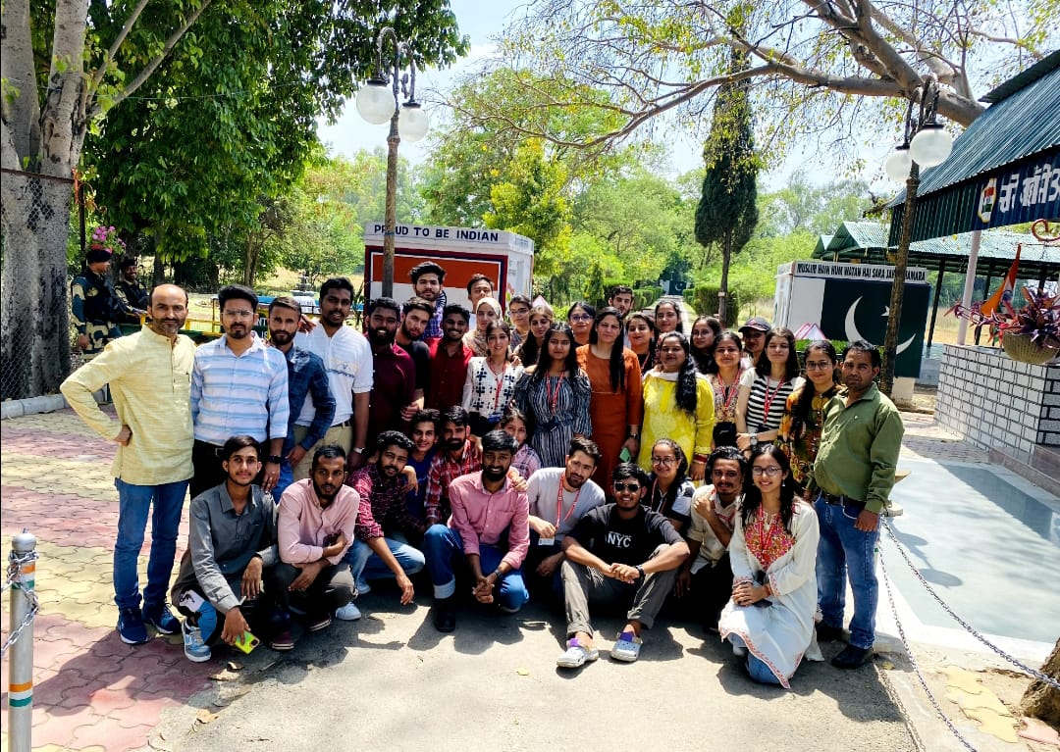
Farewell Party: On May 12, 2023, the Department of Economics hosted a farewell party in honour of the departing Batch 2021-23. The event opened with the Italian phrase "Bella Ciao," which means "Goodbye Beautiful." The juniors then put together enjoyable games for the seniors. The department head, Dr. Shaveta Kohli, spoke to the students and covered potential obstacles that might stand in the way of their career aspirations. She gave the students advice on how to get ready for their upcoming endeavours. Dr. Kohli also gave a motivational speech to the students to inspire them.

