Director, Anti Vigilance Bureau Interacts with CUJ Fraternity

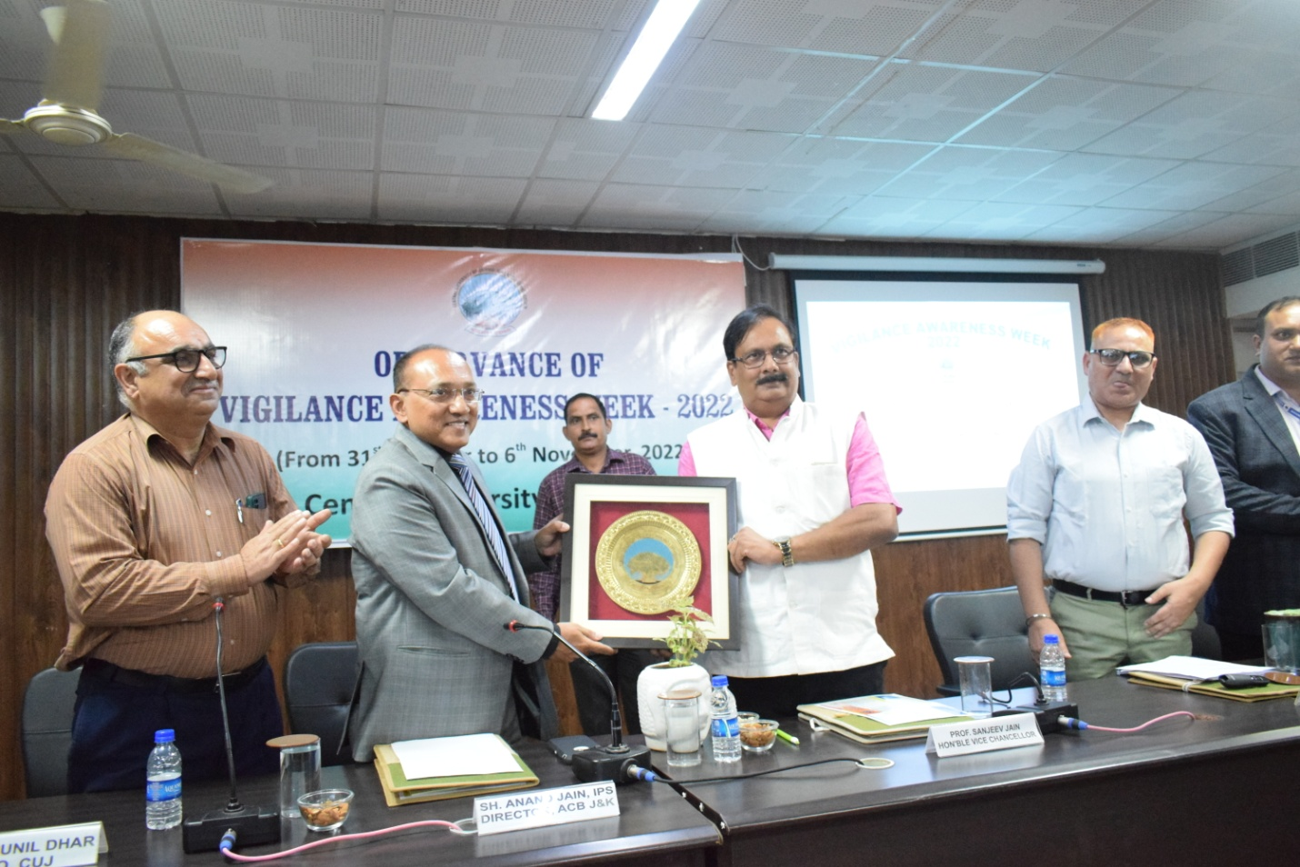
VC, Prof. Sanjeev Jain presenting a memento to Director, AVB, Sh Anand Jain

As part of ongoing weeklong Vigilance Awareness Week which began with an Integrity Pledge by all CUJ fraternity under the chairmanship of Vice Chancellor, Prof. Sanjeev Jain on National Unity Day,on 2nd November, 2022, Director, Anti Vigilance Bureau, Sh. Anand Jain IPS graced the Vigilance Awareness Week celebration as chief guest. In a stimulating session, Sh. Jain enlightened the faculty and staff members with the mission and vision of Vigilance Bureau. The programme began with a welcome note by Prof. Sunil Dhar, CVO, CUJ which was followed by a detailed presentation by Sh. Dilip Kumar, SSP, ACB, Jammu on the aims and objectives of Vigilance Bureau. This was followed by a highly interactive session wherein Director, AVB, Sh Jain responded to the volley of questions and observations of CUJ fraternity about Vigilance Bureau and its functioning. Speaking on the occasion, the chief Guest, Sh. Jain underscored the governmental priorities to make the country corruption –free. Further, Sh jain also dealt at leaght with what constitutes corruption. Speaking on the occasion, Prof. Sanjeev Jain, VC, CUJ gave a highly relevant interpretation to the term corruption, when he said that corruption is not only a monetary give and take but what is more dangerous is the corruption of mind and inaction. Prof. Yashwant Singh, Registrar, CUJ proposed the vote of thanks and explicitly conveyed the relevance of the week long celebration which is of immense national relevance. Dr. Aman, Assistant professor, Department of Education, conducted the proceedings.

