DEPARTMENT OF ENVIRONMENTAL SCIENCES
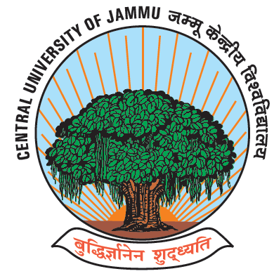
CENTRAL UNIVERSITY OF JAMMU
राया-सूचानी(बागला), जिलासांबा -181143,जम्‍मू (जम्‍मूएवंकश्‍मीर)
Rahya-Suchani (Bagla), District Samba-181143, Jammu (J &K)

Date: 26.07.2022

WALK-IN-INTERVIEW WILL BE HELD IN THE DEPARTMENT OF ENVIRONMENTAL SCIENCES, CENTRAL UNIVERSITY OF JAMMU, RAHYA-SUCHANI,BAGLA, DISTRICT SAMBA, JAMMU, 181143, J&K STATE, ON 17.08.2022 AS PER DETAILS GIVEN UNDER

1. | Name of the Temporary Post | : | Junior Research Fellow (JRF)- 02
2. | Name of the Research Project | : | "Preparation of PRI based geo-referenced biodiversity assessment  documentation and conservation plan of wild flora and fauna of Kishtwar High Altitude National Park (KHANP)
3. | Name of the Sponsoring Agency | : | National Development Foundation
4 | Tenure of the Project | : | 2 Years
5 | Tenure of the Assignment | : | 2 Years (Co-terminus with the project)
6 | Job Description | : | To carry out the field and research related work of the project.
7. | Monthly Fellowship | : | Rs. 18000/- +HRA @10% (p.m.)
8. | Essential Qualifications and experience | : | Qualification: Masters in Environmental  Sciences/Botany/Zoology/Earth Sciences,  preferably with NET. Research experience  in relevant field desirable. Candidate with high  altitude background will be preferred.  Age relaxation will be given to the candidates as per Govt. of India rules. The project fellowship is a full time position. The selected candidate shall not draw money from any other source.
 |  | :
9. For technical information on the project, the candidate may contact the Principal
Investigator (PI) or Co-Principal Investigator (Co- PI) at the following address:

Name : Prof. Sunil Dhar (PI)

Address : Department of Environmental Sciences
Central University of Jammu, J&K State, 181143
Telephone No : 9418085940
E-mail : sunil.evs@cujammu.ac.in

Name : Dr. Richa Kothari (Co-PI)

Address : Department of Environmental Sciences
Central University of Jammu, J&K State, 181143
Telephone No : 7006003549
E-mail : richa.evs@cujammu.ac.in

NOTE

- Candidates before appearing for the interview shall ensure that they are eligible for the position they intend to apply.

- Candidates desiring to appear for the Walk in Interview should carry with them following documents:
a) Application in a plain paper with detailed CV including chronological discipline of
degree/ certificates obtained.

b) Attested copies of degree / certificate and experience certificate.

c) Original degree {s) / certificates and experience
certificates for verification

3, No TA/DA is admissible for attending the interview

Prof Sunil Dhar
PI

