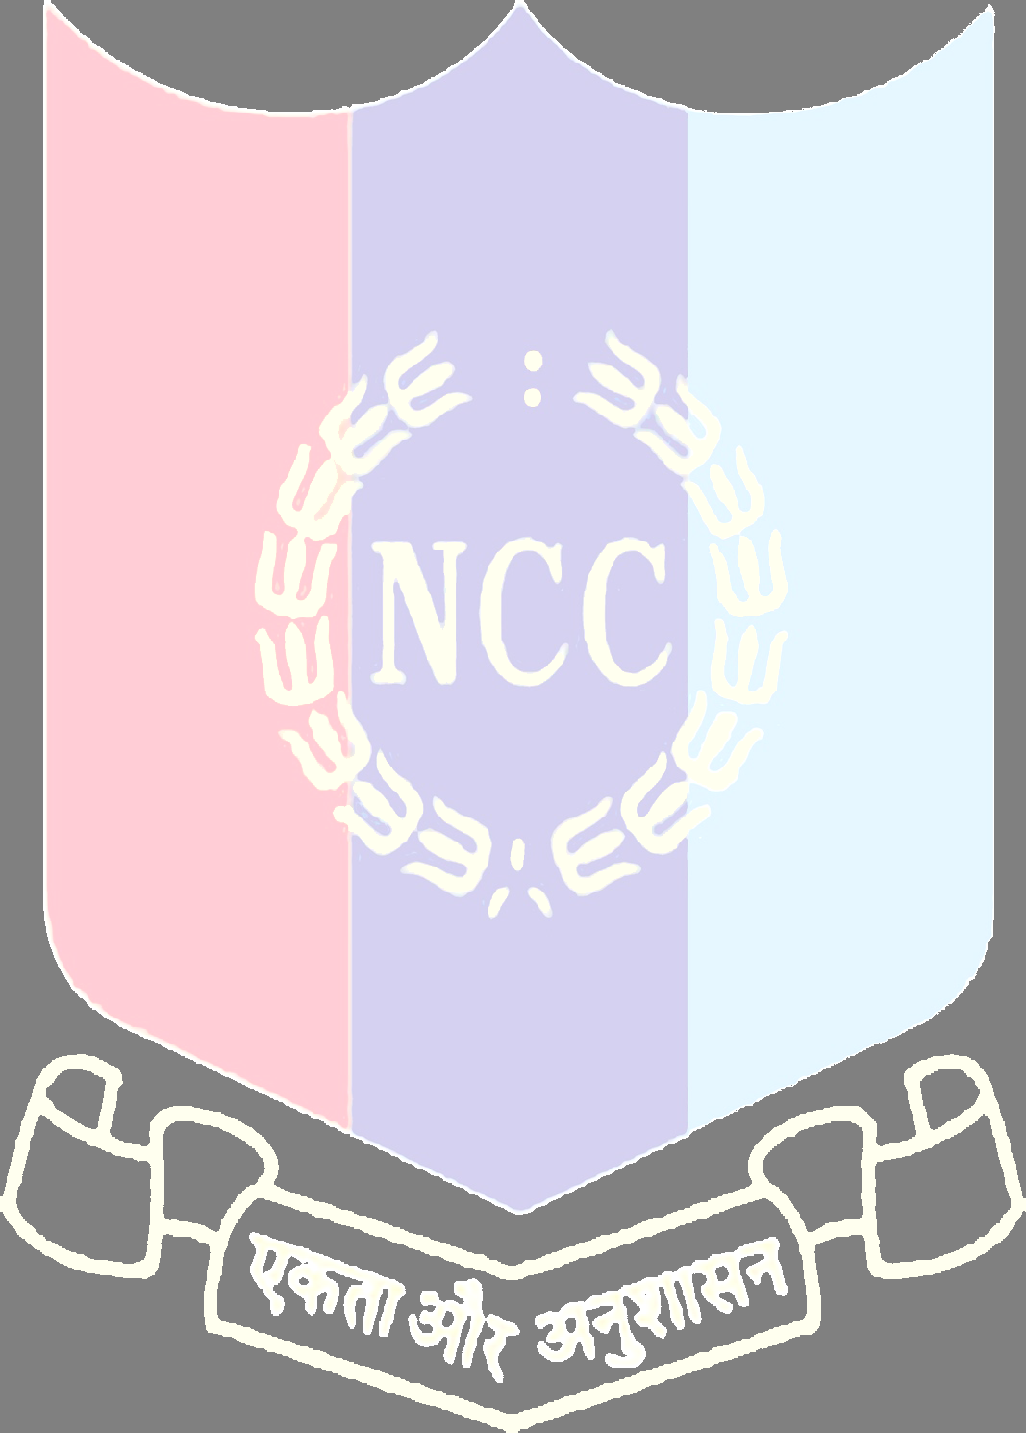
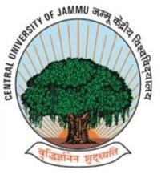
NCC UNIT OF CENTRAL UNIVERSITY OF JAMMU CELEBRATED 74TH NCC DAY ON 27TH NOVEMBER ,2022

Jammu 27 November 2022: The NCC unit of Central University of Jammu celebrated 74TH NCC day in the virtual mode on the online Google platform. The event was organized by the Cadets under the patronage of ANO Lt. Dr. Pankaj Mehta, with full of enthusiasm and the feeling of patriotism.
The National Cadet Corps (NCC), is the youth wing of the Indian Armed Forces and the largest uniformed youth organization in the world, It is celebrated on the 4th Sunday every year in the month of November as NCC day throughout the country where cadets participate in blood donation camps and rallies.
The Event started with the Brief Introduction Of History, Motto and Benefits of NCC in today’s world. The message of Directorate General of NCC was screened in. Also the Message of the Commanding officer of Officer training Academy Kamptee was screened in.
Then The ANO Lt. Dr. Pankaj Mehta Motivated the Cadets to follow discipline and taught the basic structure of NCC. SUO Amit Anand coordinated the event and recited the NCC
song, “HUM SAB BHARTIYA HAE” along with cadet Satyam and Team. Then followed by this Cadet Sourav Sharma Gave a short and crisp note speech on NCC day and welcomed all the cadets on the behalf of ANO Sir and 4TH J&K NCC BN. He shared some views on importance and scope of NCC among the youth. He told the Importance of NCC in today’s scenario. Followed by this a melodious Song Performance was displayed by Prerna from BA. Bed. Department.
Then Cadet Abhisek Presented a tremendous and remarkable presentation on NCC Day.

Followed by this Cadet Suryakant Recited A heart touching Poem of A soldier on border.
Finally at Last, The National Anthem was played and
Everyone Stood up And Sung, “JAN GAN MAN ATINAYAK…”
At last ANO Lt. Dr. Pankaj Mehta Wished best of luck to All The cadets and the event Ended with The loud Speaking of, “BHARAT MATA KI JAY”.

JAI HIND!!!!

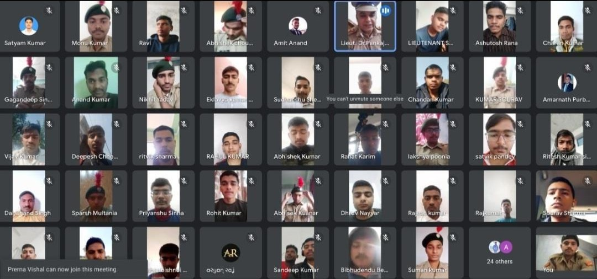

Snapshot: Celebration of 74th NCC day by NCC Unit of Central University of Jammu in virtual mode.

