CENTRAL UNIVERSITY OF JAMMU
FACULTY PROFILE PERFORMA
First Name | Vishal | Middle Name |  | -- | Last Name | -- | Photograph
Title & Designation |  | Mr. and Assistant Professor |  |  |  |  | 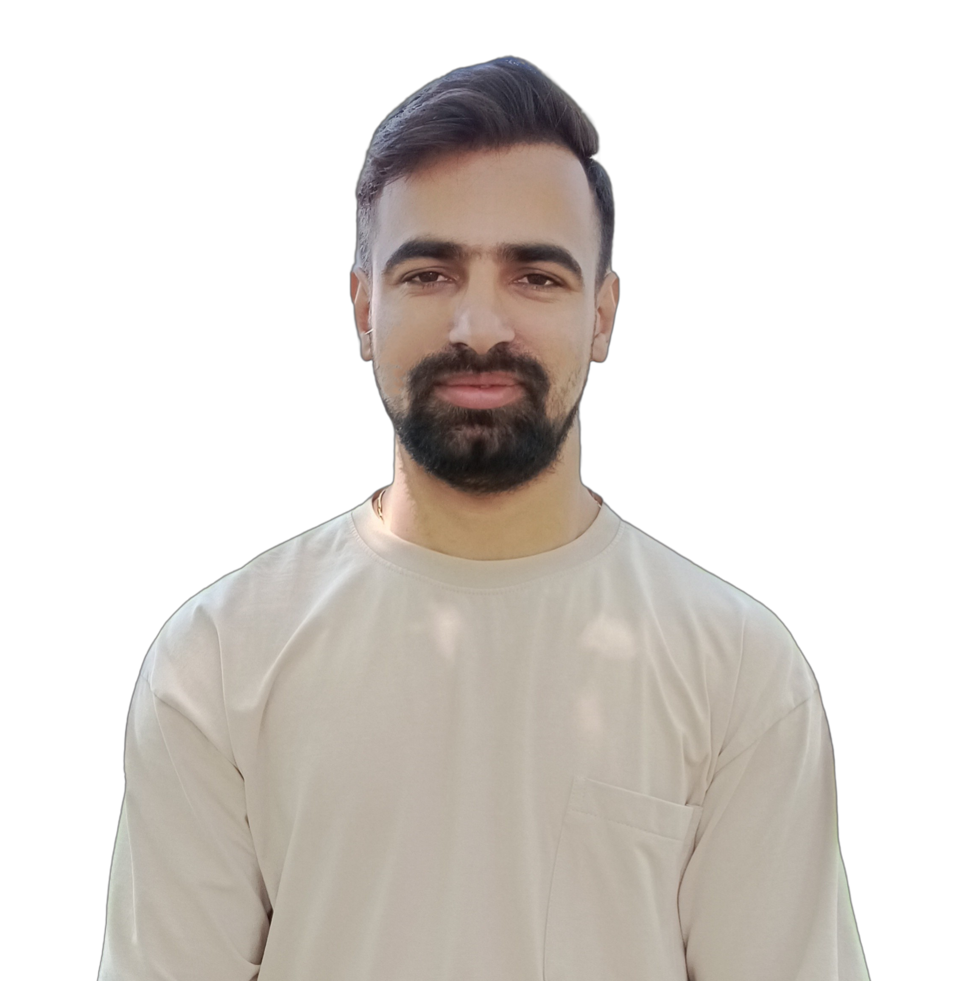
Address |  | Department of Economics, Central University of Jammu, Jammu and Kashmir
Mobile |  | +91-9991213108
Email |  | Vishal.eco@cujammu.ac.in
Web-Page
Educational Qualifications:
Degree |  |  | Institution |  |  |  |  | Year
B.A. Economics Hons. |  |  | D.A.V. College, Sector-10, Chandigarh-160010 |  |  |  |  | 2013
M.A. Economics |  |  | Department of Economics, Punjab University, Chandigarh-160014 |  |  |  |  | 2015
UGC- NET |  |  | UGC |  |  |  |  | 2016
PhD Economics (Viva awaited) |  |  | Centre for Research in Rural and Industrial Development, Sector-19, Chandigarh-160019 |  |  |  |  | 2023
Career Profile:

Worked as Assistant Professor (Adhoc) at D.A.V. College, Chandigarh-160010.
Research Assistant for University of Guelph, Canada; ISS, Netherlands and CRRID,
Chandigarh.
Researcher at HISP India.
Assistant Professor at GGDSD College, Chandigarh-160032.
Administrative Assignments:
Areas of Interest / Specialization:
Health Economics, Population Studies, Indian Economy, Statistical methods and softwares
Subjects Taught:
Development Economics, Indian Economy, International Trade, Population Studies
Research Guidance:
Publications Profile:
- Research Paper: 3
- Towards Universal Health Care: India”, published in peer reviewed journal: Scholarly Research Journal for Interdisciplinary Studies, ISSN No. 2278 – 8808, SJIF 2018: 6.371
- A Critical Appraisal of Impact of COVID-19 on Elderly in India”, Health and Population: Perspectives and Issues, ISSN- 0253-6803, Volume 44, Number 4, October-December 2021
- Elderly and their Rights: A Case Study of Haryana”, The Journal of Oriental Research Madras, ISSN No. 0022-3301, Volume XCII, 2022
- Chapter in books: 2
- India and BRICS relations”, ISSN/ISBN No. 978-93-89657-59-3, Bharti Publications, New Delhi, 2020
- Ayushman Bharat: World’s Largest Public Health Scheme”, ISSN/ISBN No. 978-81-947735-6-6, Sharp Mind Publishers and Distributors, 2020

c. Journal Volume
d. Paper Presentations: 4
i) Impact of Covid-19 on elderly in India” presented at the Annual Conference of Indian Association for the Study of Population (IASP), November 28-30, 2020.
ii) Impact of Covid-19 on Migration and Health in India” at the Annual Conference of Indian Association for the Study of Population (IASP), November 28-30, 2020
- Elderly and their Rights: A Case Study of Haryana” at the International E-conference on Human Rights, 12 March 2022
- Factors affecting Out-of-pocket and catastrophic health expenditure: Evidence from a case study of Haryana, India” presented at CIRCLE Graduate South Asia Conference, 29 September to 01 October 2022

Conference / Workshops/Training Organized:
15-Days Workshop on Empirical Economics and Tools conducted by Department of Economics, GGDSD College, Chandigarh (February-April, 2023)
Creation of ICT Mediated Teaching Learning Pedagogy and Content:
NA
Conference/Workshops/Training attended as Faculty Member:
--
Invited Lectures/Resource Persons:
15-Days Workshop on Empirical Economics and Tools conducted by Department of Economics, GGDSD College, Chandigarh (February-April, 2023)
Research Projects (Major Grants/Research Collaboration):
--
Awards and Distinctions:
Awarded Indian Council of Social Science Research (ICSSR) National Doctoral Fellowship (Centrally Administered) for Two Years (2021-2022) in Economics
Association with Professional Bodies:
Other Activities:

